**MIDLANDS THEATRE(MT) COMPANY**

Data Mart Design

**ASSIGNMENT BY ANNE AWELE NWAOKOLO- P2743914**

**Data Warehouse Design and OLAP**

**IMAT 5167**

**DELIVERABLES**

**1.1 STAR SCHEMA DESIGN**

**P2743914­_CLIENT**

**Dimension**

**Client_id PK**

Client#

**Title**

Name

**Theatre_Id PK**

Theatre#

Name

**P2743914_THEATRE**

Dimension

**1.2 EXPLANATION OF STAR SCHEMA**

**P2743914_TIME**

**Dimension**

**P2743914­­_TICKETSALES**

**Fact**

Theatre_Id FK

Prod_Id FK

Purchase**_id**, FK

time_id FK

SalesValue

**P2743914_PRODUCTION**

**Dimension**

**Prod_Id PK**

P#

Title

**Time_id PK**

Month

year

**a and b**

**P2743914_theatre – Dimension-** This table is required to get the details of the theatre and the required attributes are **Theatre_Id, Theatre#, name**. The table and the attributes are chosen because the analysis requires us getting the details of theatre with the highest spending.

**P2743914_production – Dimension**- This table is required to enable us get information on sales for each production as required in the analysis.

Required attributes are **P_Id, P#, Title** all these contain information on the production and will be used in the analysis.

**P2743914_Client – Dimension-** This table is required to extract information for our clients as the analysis requires finding out which clients have the highest spending. attributes required are **Client_id , PK Client# ,Title, Name** each of these attributes give us information of clients as expected in the analysis.

**P2743914_time – Dimension-** in the analysis, we are expected to get monthly sales value of each theatre so a table with time details is needed for this analysis and the required attrbutes are **Time_id, month, year**

**P2743914_Ticketsales-Fact-** I have chosen ticketsales as my fact table this is because the main requirement of all the analysis borders around getting the value of sales for tickets and I have choses to include all the primary keys from my dimension tables to complete the star schema, these foreign keys are referencing the primary keys from all the dimension tables the attrtibutes include **Theatre_Id, P_Id,Purchase_id, time_id , SalesValue** I included an additional attribute for the value of sales as the fact data.

**c. Granularity**

Time grain- Month

Theatre grain-Total sales value specific theatre

production grain -Monthly sales value for a specific production

theatre client-specific theatre and specific clients with highest spending

**2. DERIVATION OF LOGICAL RELATIONS**

**2.1 LIST OF LOGICAL RELATIONS**

**P2743914_theatre –** (Theatre_Id PK, Theatre#, name)

**P2743914_production –** (P_Id PK **,** P#**,** Title)

**P2743914_Client –** (Client_id PK, Client# ,Title, Name )

**P2743914_time – Dimension-** (time_id PK, month, year)

**P2743914_Ticketsales-Fact-** (Theatre_Id FK, Prod_Id FK ,Purchase_id FK, time_id FK , SalesValue)

**2.2 EXPLANATION ON THE MAPPING FROM STAR SCHEMA TO THE LOGICAL RELATIONS**

Theatre_Id is a foreign key referring to the dimension table P2743914_theatre

P_Id is a foreign key referring to the dimension table P2743914_production

Client_id is a foreign key referring to the dimension table P2743914_ Client

time_id is a foreign key referring to the dimension table P2743914_time

these foreign keys form the composition of the primary keys of the fact table P2743914_Ticketsales.

Theatre_Id, P_Id, Client_id, time_id are surrogate keys while Theatre#, P#, Client# are the Nature keys

**3. CREATION OF TABLES**

**P2743914_THEATRE TABLE**

CREATE SEQUENCE P2743914_theatre_seq

START WITH 1

INCREMENT BY 1

NOCACHE

NOCYCLE;

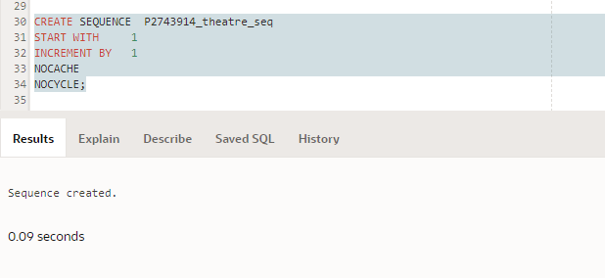

create Table P2743914_Theatre(

Theatre_Id NUMBER(3)PRIMARY KEY,

Theatre# NUMBER(5)NOT NULL ,

Name VARCHAR2 (20) NOT NULL);

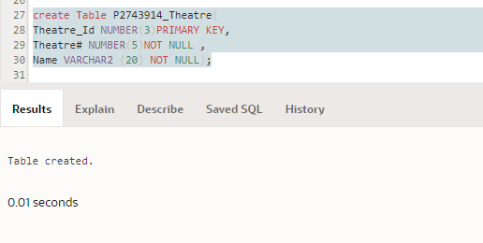

**P2743914_PRODUCTION TABLE**

CREATE SEQUENCE P2743914_production_seq

START WITH 1

INCREMENT BY 1

NOCACHE

NOCYCLE;

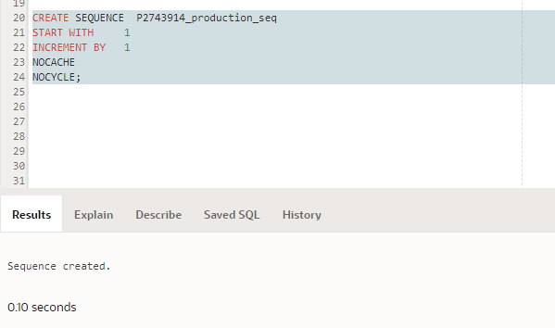

Create Table P2743914_production(

P_Id NUMBER(5) PRIMARY KEY,

P# NUMBER(5) NOT NULL,

Title VARCHAR2 (20) NOT NULL);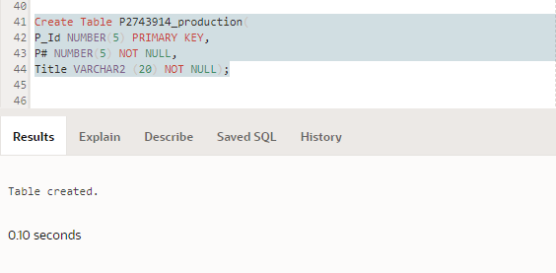

**P27439214_CLIENT TABLE**

CREATE SEQUENCE P2743914_client_seq

START WITH 1

INCREMENT BY 1

NOCACHE

NOCYCLE;

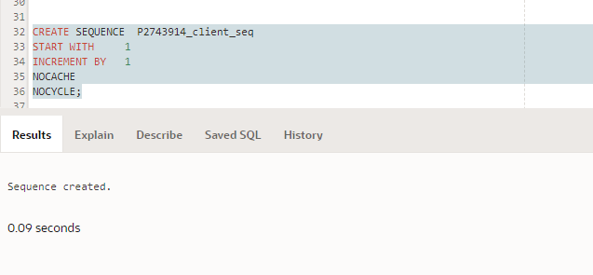

Create Table P2743914_client(

Client_Id NUMBER(5)PRIMARY KEY,

Client# NUMBER(5) NOT NULL,

Title VARCHAR2(10),

Name VARCHAR2(30) NOT NULL);

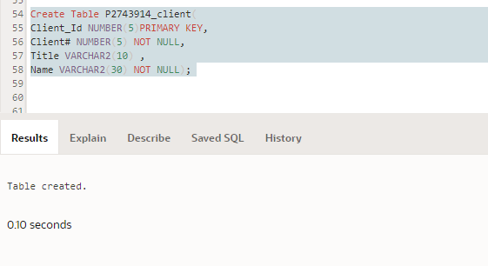

**P2743914_TIME TABLE**

CREATE SEQUENCE P2743914_time_seq

START WITH 1

INCREMENT BY 1

NOCACHE

NOCYCLE;

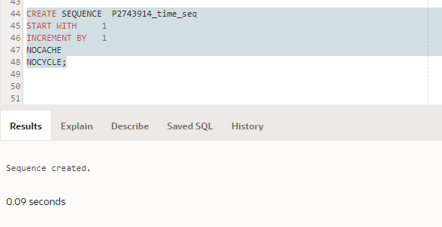

CREATE TABLE P2743914_time(

time_id number(5)PRIMARY KEY,

year number(4) NOT NULL,

month number(2) NOT NULL);

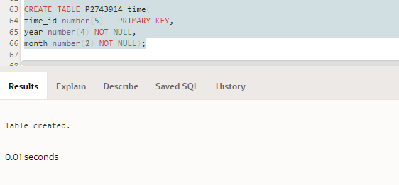

**P2743914_TICKETSALES TABLE**

create Table P2743914_ticketsales(

THEATRE_Id NUMBER(5) CONSTRAINT FK_P2_ticketsales REFERENCES P2743914_Theatre,

P_Id NUMBER(5)CONSTRAINT FK_7_ticketsales REFERENCES P2743914_production,

Client_Id NUMBER(5) CONSTRAINT FK_P4_ticketsales REFERENCES P2743914_client,

Time_Id NUMBER(3) CONSTRAINT FK_P3_ticketsales REFERENCES P2743914_time,

Totalsales NUMBER (20,2) NOT NULL,

CONSTRAINT PK_P2743914_ticketsales PRIMARY KEY (THEATRE_Id,P_Id,Client_Id,Time_Id));

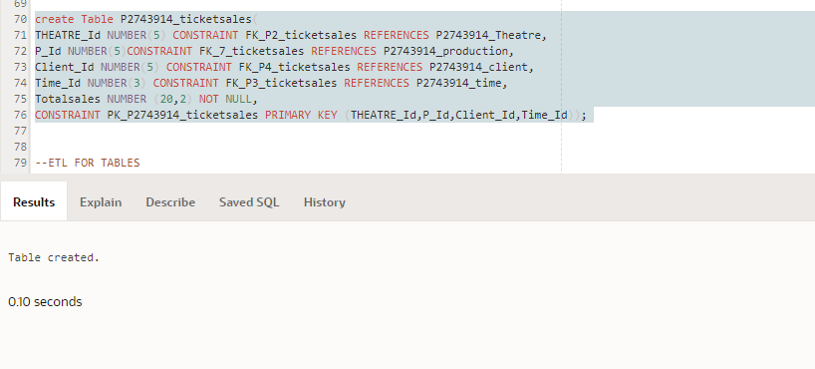

**4. DATA SOURCE IDENTIFICATION, DATA EXTRACTION, TRANSFORMATION AND LOADING**

**4.1 DATA SOURCE MAPPING**

Theatre joins Performance

joins TicketPurchase

Theatre#

name

…

pdate

Totalamount

P2743914_Theatre

Theatre#

name

Format

Format

P2743914_time

time_id

year

month

P2743914_Ticketsales

Time_id

Totalsales

Production joins performance joins Ticket Purchase

P#

Title

…

pdate

Totalamount

P2743914_Production

P#

title

Format

Format

P2743914_time

time_id

year

month

P2743914_Ticketsales

Time_id

Totalsales

Client join ticketpurchase

Client#

Title

name

…

Totalamount

P2743914_client

Client#

Title

name

Format

Format

P2743914_Ticketsales

Totalsales

**4.2 AND 4.3 – ETL CODES AND EVIDENCE OF CODES WORKING(SCREENSHOT)**

**P2743914_THEATRE**

insert into P2743914_Theatre select P2743914_Theatre_seq.nextval, Theatre#, name from

(select distinct Theatre#, upper(trim(name)) name

from

(select ops$yyang00.theatre.Theatre# Theatre#, ops$yyang00.theatre.name name

From ops$yyang00.theatre,ops$yyang00.performance,ops$yyang00.ticketpurchase

Where ops$yyang00.theatre.Theatre#=ops$yyang00.performance.Theatre# and ops$yyang00.performance.per#=ops$yyang00.ticketpurchase.per# ));

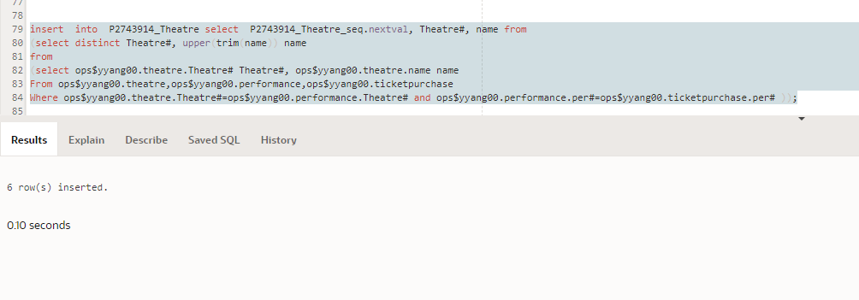

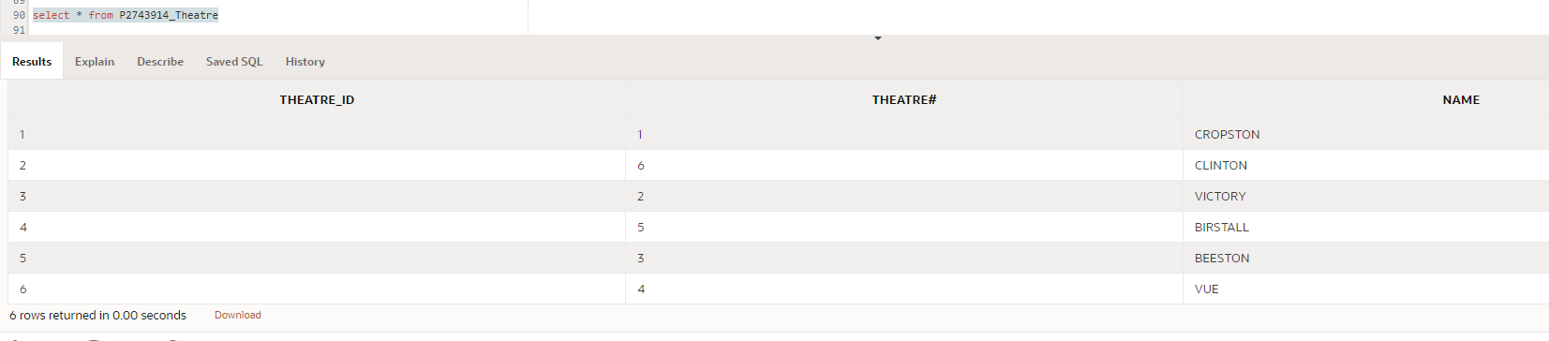

**P2743914_PRODUCTION**

insert into P2743914_Production select P2743914_Production_seq.nextval, P#, title from

(select distinct P#, upper(trim(title)) title

from

(select ops$yyang00.production.P# P#, ops$yyang00.Production.title title

From ops$yyang00.production,ops$yyang00.performance,ops$yyang00.ticketpurchase

Where ops$yyang00.production.P#=ops$yyang00.performance.P# and ops$yyang00.performance.per#=ops$yyang00.ticketpurchase.per# ));

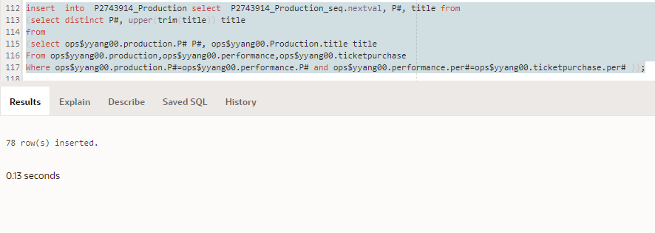

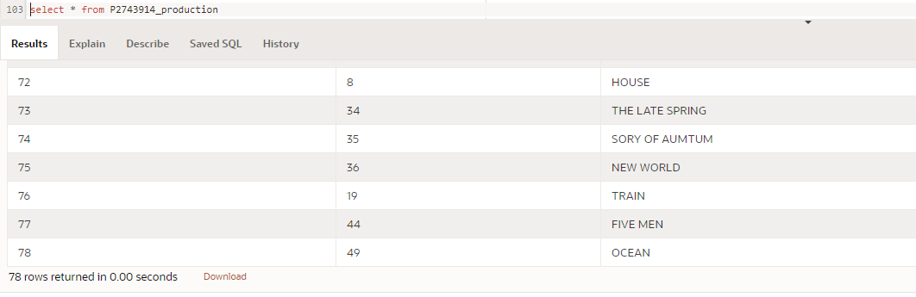

**P2743914_CLIENT**

insert into P2743914_Client select P2743914_client_seq.nextval, Client#,Title,Name from

(select distinct Client#, upper(trim(Title)) Title, upper(trim(Name)) Name

from

(select ops$yyang00.Client.Client# Client#, ops$yyang00.Client.Title Title, ops$yyang00.Client.name name

From ops$yyang00.client,ops$yyang00.ticketpurchase

Where ops$yyang00.client.client#=ops$yyang00.ticketpurchase.client# ));

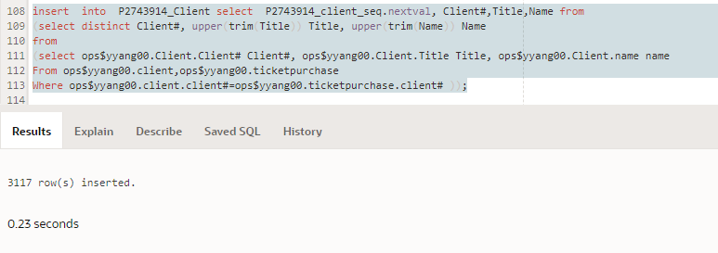

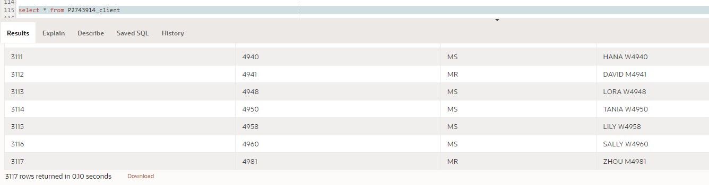

**P2743914_TIME**

insert into P2743914_time select P2743914_time_seq.nextval, year, month from

(select distinct extract(year from pdate) year, extract(month from pdate) month from ops$yyang00.performance);

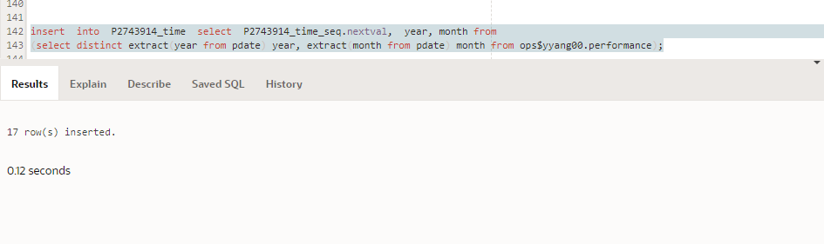

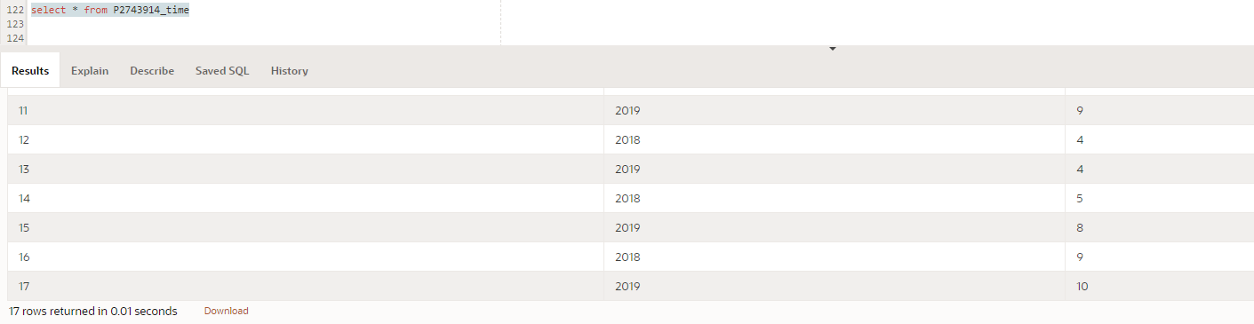

**P2743914_TICKETSALES**

Insert into P2743914_ticketsales Select Theatre_Id,P_Id,Client_Id,Time_Id, totalsales from

(select P2743914_Client.Client_id, P2743914_Theatre.Theatre_id,P2743914_Production.P_Id, P2743914_time.Time_Id, sum(totalamount)Totalsales

from P2743914_Client, P2743914_Theatre,P2743914_time,P2743914_Production,ops$yyang00.ticketpurchase,ops$yyang00.performance

where ops$yyang00.ticketpurchase.Client# = P2743914_Client.Client# and ops$yyang00.performance.Theatre#=P2743914_Theatre.Theatre#

and P2743914_Production .P#=ops$yyang00.performance.P#

and ops$yyang00.ticketpurchase.per# = ops$yyang00.performance.per# and extract (year from ops$yyang00.performance.pdate)=P2743914_time.year

and extract (month from ops$yyang00.performance.pdate)= P2743914_time.month

group by P2743914_Client.Client_id, P2743914_Theatre.Theatre_id, P2743914_Production.P_Id, P2743914_time.Time_Id);

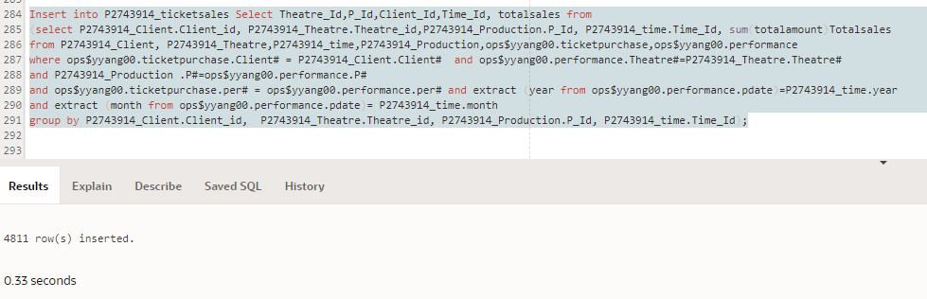

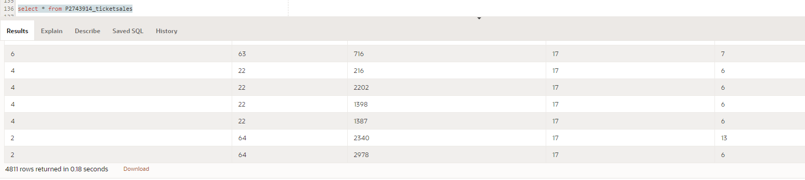

**5. JUSTIFICATION OF THE DATA MART DESIGN AND COMPARISON OF DATA MART AND OLTP**

**5.1 SQL CODE FOR THE REQUIRED QUERIES**

**ANALYSING TOTAL SALES VALUE OF EACH PRODUCTION**

**DATA MART**

select P2743914_Production.p_id, P2743914_Production.title, sum(totalsales)

from P2743914_Production, P2743914_ticketsales

where P2743914_Production.p_id=P2743914_ticketsales.p_id

group by P2743914_Production.p_id, P2743914_Production.title

order by P2743914_Production.p_id

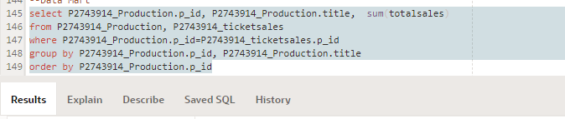

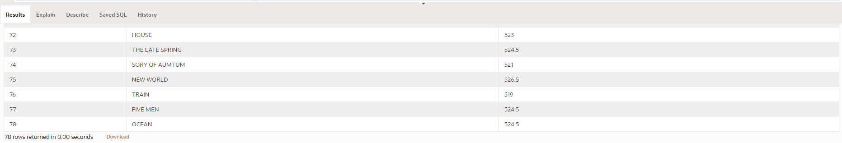

**RELATIONAL MODEL**

select ops$yyang00.production.P# P#, ops$yyang00.Production.title title,sum(totalamount)

From ops$yyang00.production,ops$yyang00.performance,ops$yyang00.ticketpurchase

Where ops$yyang00.production.P#=ops$yyang00.performance.P# and ops$yyang00.performance.per#=ops$yyang00.ticketpurchase.per#

group by ops$yyang00.production.p#, ops$yyang00.production.title

order by ops$yyang00.production.p#

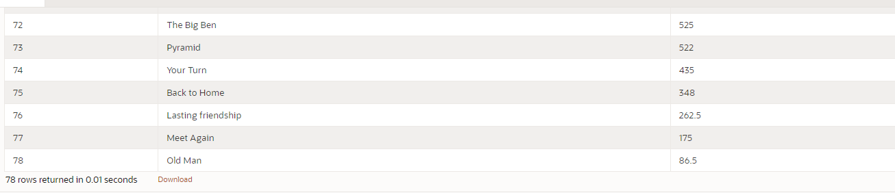

**ANALYSING MONTHLY SALE VALUE OF EACH THEATRE**

**DATA MART**

select P2743914_theatre.theatre_id, P2743914_theatre.name, P2743914_time.year, P2743914_time.month, sum(totalsales)

from P2743914_theatre,P2743914_time,P2743914_ticketsales

where P2743914_theatre.theatre_id=P2743914_ticketsales.theatre_id and P2743914_time.time_id=P2743914_ticketsales.time_id

group by P2743914_theatre.theatre_id, P2743914_theatre.name, P2743914_time.year, P2743914_time.month;

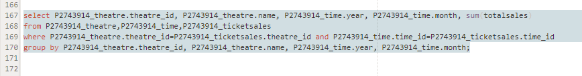

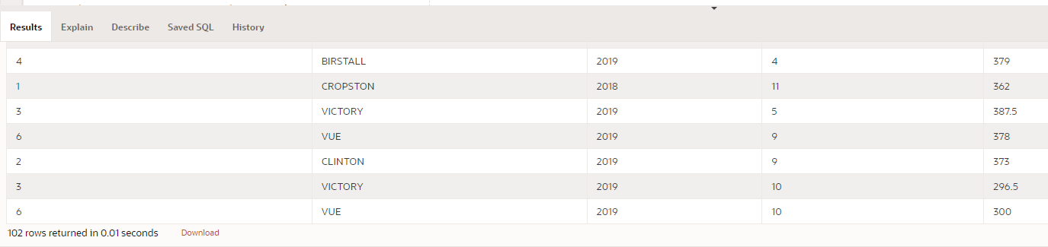

**RELATIONAL DATA MODEL**

select ops$yyang00.theatre.theatre#,ops$yyang00.theatre.name, extract(year from pdate), extract(month from pdate), sum(totalamount)

from ops$yyang00.theatre, ops$yyang00.performance, ops$yyang00.ticketpurchase

where ops$yyang00.theatre.Theatre#=ops$yyang00.performance.Theatre# and ops$yyang00.performance.per#=ops$yyang00.ticketpurchase.per#

group by ops$yyang00.theatre.theatre#,ops$yyang00.theatre.name, extract(year from pdate), extract(month from pdate);

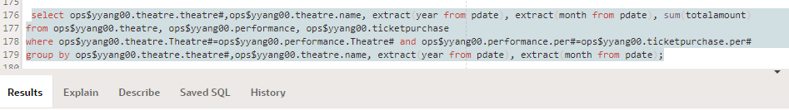

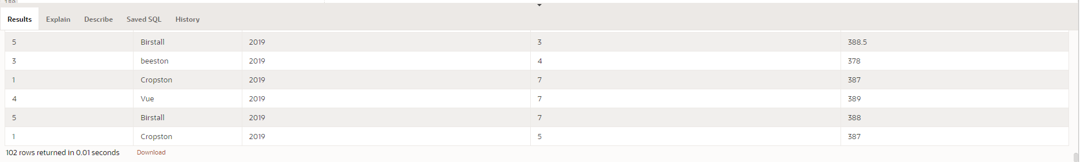

**ANALYSING THE CLIENT NAME WITH HIGHEST SPENDING IN EACH THEATRE**

select T1.name,T1.theatre_id,TS1.totalsales,C1.name,C1.client_id from P2743914_client C1, P2743914_theatre T1, P2743914_ticketsales TS1 where totalsales=(

select max(totalsales) from P2743914_client C2, P2743914_theatre T2, P2743914_ticketsales TS2

where T1.name=T2.name

and TS1.client_id =C1.client_id

and TS2.client_id=C2.client_id)

**DATA MART**

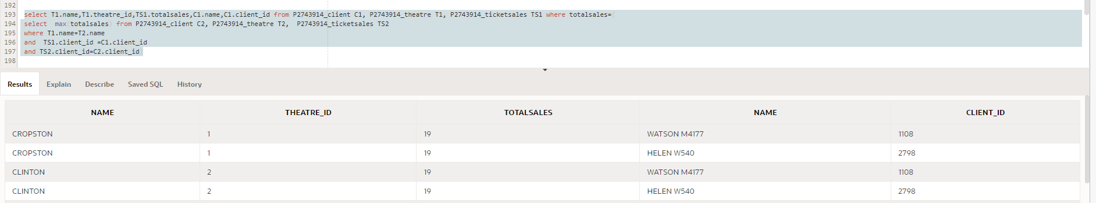

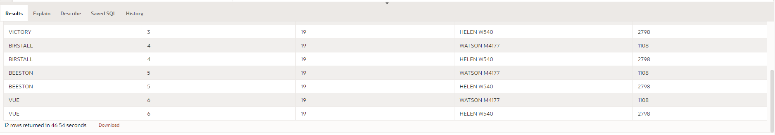

**RELATIONAL DATA MODEL**

select ops$yyang00.Client.Client#, ops$yyang00.Client.name,ops$yyang00.theatre.Theatre#, ops$yyang00.theatre.name name,totalamount

from ops$yyang00.client,ops$yyang00.ticketpurchase,ops$yyang00.performance,ops$yyang00.theatre

where ops$yyang00.ticketpurchase.Per#=ops$yyang00.performance.Per#

and ops$yyang00.client.client#=ops$yyang00.ticketpurchase.client#

and ops$yyang00.theatre.Theatre#=ops$yyang00.performance.Theatre#

and totalamount=

(select max(totalamount) from ops$yyang00.client,ops$yyang00.ticketpurchase,ops$yyang00.performance,ops$yyang00.theatre

Where ops$yyang00.theatre.name=ops$yyang00.theatre.name

and ops$yyang00.ticketpurchase.Per#=ops$yyang00.performance.Per#

and ops$yyang00.client.client#=ops$yyang00.ticketpurchase.client#

and ops$yyang00.theatre.Theatre#=ops$yyang00.performance.Theatre#)

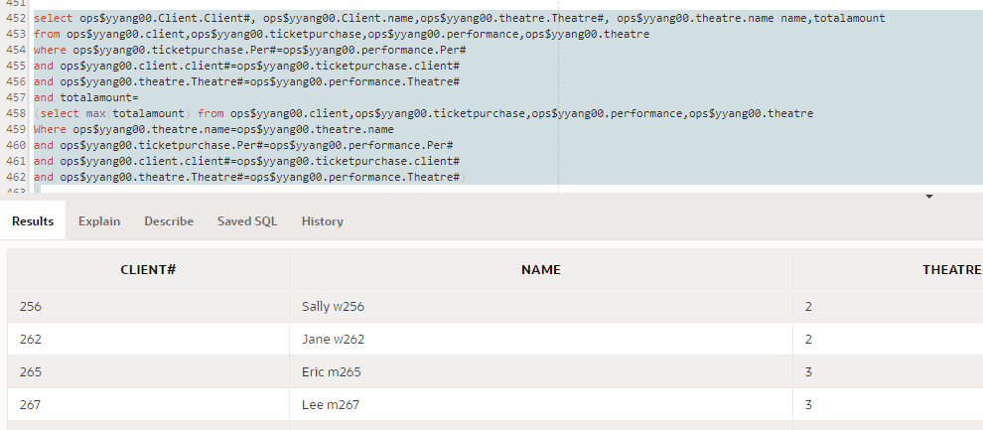

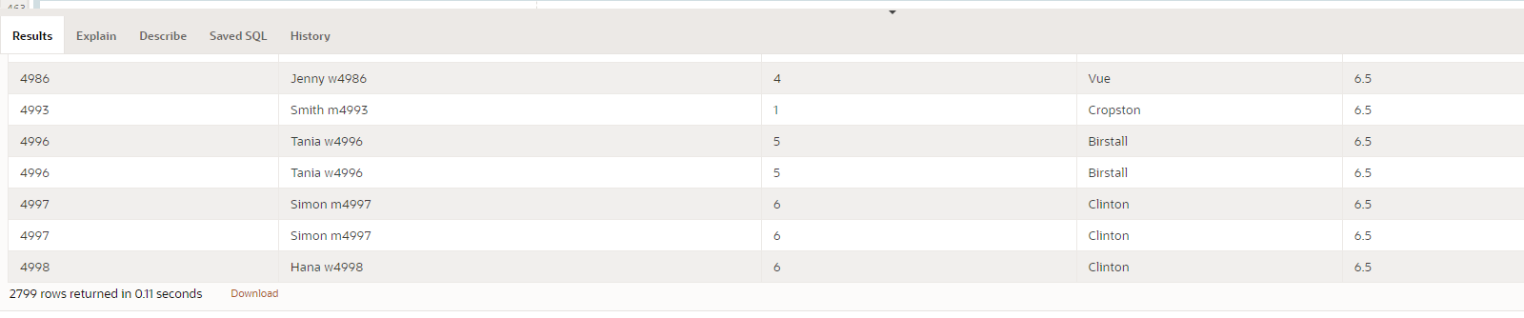

**JUSTIFICATION OF THE DATA MART DESIGN.**

The Data Mart is required to assist to have a business intelligence view on the ticket sales. As compared to the Relational Model, The Data Mart focuses on information for Tickets sales.While designing the Star Schema, the major thing to look out for is the Analysis requirement. In the case of Midlands Theatre, the Data mart is expected to analyse the Total Sales Value of each production, The Monthly Sales Value of each theatre and the theatre name (for each theatre) and the names of clients who have the highest spending in that theatre.

Based on this analysis, the required tables are;

1. **Theatre Table** -To get the details of monthly sales value of the theatre and the theatre name for each theatre to know which clients have the highest spending in that theatre.

For the Theatre table, in order to get the total amount from the ticket purchase table we have to link the performance table since there is no direct link with theatre and ticket purchase the performance serves as the link to the two tables.

1. **Production Table**- To get the details of total sales value of each production, for us to get the total amount from the ticket purchase table, we have to link the performance table which serves as a link between the two tables.
2. **Client table**- To get the details of clients with highest spending in each theatre, Client table is directly linked to the Ticket purchase table so we only join client to ticket purchase based on the analysis requirement.
3. **Time Table**- in order to get information on timely basis such as monthly, the table for time has to be created
4. **Ticketsales**- This table contains the main fact of the analysis which is sales value(totalsales). It contains all the primary keys as foreign keys and totalsales as the main requirement for the analysis.

The Data mart makes it easier and more efficient to retrieve data for the required analysis.

**COMPARISM OF THE DATA MART AND RELATIONAL DATA MODEL**

**ANALYSING TOTAL SALES VALUE OF EACH PRODUCTION**

In the Data Mart, to get the total sales of each production the query used in getting the result for is much easier and straightforward since the fact table (Ticketsales) is linked directly to the production table. The Production table is simply joined with the ticket sales table to get the amount. For the relational data model, the query for getting the results seems a lot more complex as there is no link from the production table to the ticket purchase there has to be a join to the performance table. Despite the differences in both queries used, the results from the data mart are exactly the same as the one from the relational data base in regards to the total amount.

**ANALYSING MONTHLY SALE VALUE OF EACH THEATRE**

In the Data Mart, to get the monthly sales value for each theatre we linked the theatre table to the ticket sales and time table. This query meets the analysis requirement and is very straightforward. The Theatre table is joined to the tickets sales to get the totalsales figures and also linked to time table to get the dates for months. For the relational data model, the theatre table is joined to the ticket sales to get the figures for total amount and joined with the performance table to get the dates for monthly values. The query for the relational data base seems a lot more complicated but a review of the output for total amount shows the same figures for both the relational data model and the data mart.

**ANALYSING THE CLIENT’S NAME WITH HIGHEST SPENDING IN EACH THEATRE**

For the Client name with the highest spending in each theatre, to get the get the best result, the focus is on the joining conditions, the first query gets the names of the clients and theatre and total amount sold to them while a subquery is included for the maximum(highest) amount. In the data mart the joining conditions is lesser because the Data mart has been more streamlined to captured details for ticketsales. For the relational data base the joined conditions is quite complex and produces large output.